BANK LOAN REPORT QUERY
KPI’s:
1.Total Loan Applications
select COUNT(id) AS Total_Loan_Applications from bank_loan_data
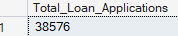

- MTD Loan Applications
select COUNT(id) AS MTD_Total_Loan_Applications from bank_loan_data
where MONTH(issue_date)=12

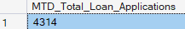

- PMTD Loan Applications
select COUNT(id) AS MTD_Total_Loan_Applications from bank_loan_data
where MONTH(issue_date)=11

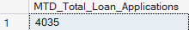

2. Total Funded Amount
select SUM(loan_amount) as Total_Funded_Amount from bank_loan_data
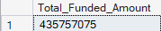

- MTD Total Funded Amount
select SUM(loan_amount) as MTD_Total_Funded_Amount from bank_loan_data
WHERE MONTH(issue_date) =12 and YEAR(issue_date) =2021
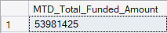

- PMTD Total Funded Amount
select SUM(loan_amount) as PMTD_Total_Funded_Amount from bank_loan_data
WHERE MONTH(issue_date) =11 and YEAR(issue_date) =2021
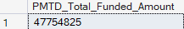

3.Total Amount Received
select SUM (total_payment) as Total_Amount_Received from bank_loan_data
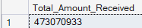

- MTD Total Amount Received
select SUM (total_payment) as MTD_Total_Amount_Received from bank_loan_data
WHERE MONTH(issue_date) =12 and YEAR(issue_date) =2021
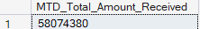

- PMTD Total Amount Received
select SUM (total_payment) as PMTD_Total_Amount_Received from bank_loan_data
WHERE MONTH(issue_date) =11 and YEAR(issue_date) =2021
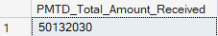

4. Average Interest Rate
select ROUND (AVG(int_rate),4)*100 as Avg_Interest_Rate from bank_loan_data
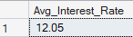

- MTD Average Interest Rate
select ROUND (AVG(int_rate),4)*100 as MTD_Avg_Interest_Rate from bank_loan_data
WHERE MONTH(issue_date) =12 and YEAR(issue_date) =2021
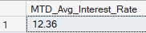

- PMTD Average Interest Rate
select ROUND (AVG(int_rate),4)*100 as PMTD_Avg_Interest_Rate from bank_loan_data
WHERE MONTH(issue_date) =11 and YEAR(issue_date) =2021
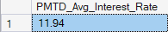
5.Average Debt-to-Income Ratio (DTI)
select ROUND (AVG(dti),4) *100 as Avg_DTI from bank_loan_data
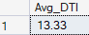

- MTD Average Debt-to-Income Ratio (DTI)
select ROUND (AVG(dti),4) *100 as MTD_Avg_DTI from bank_loan_data
WHERE MONTH(issue_date) =12 and YEAR(issue_date) =2021

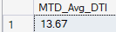

- PMTD Average Debt-to-Income Ratio (DTI)
select ROUND (AVG(dti),4) *100 as PMTD_Avg_DTI from bank_loan_data
WHERE MONTH(issue_date) =11 and YEAR(issue_date) =2021

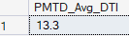

Good Loan vs Bad Loan KPI’s
Good Loan
1.Good Loan Application Percentage
select (COUNT (CASE WHEN loan_status = 'Fully paid' OR loan_status = 'Current' THEN id END )*100)
/COUNT (id) as Good_Loan_Percentage from bank_loan_data
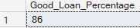

2. Good Loan Applications
select COUNT(id) as Good_Loan_Applications from bank_loan_data
where loan_status = 'Fully paid' OR loan_status = 'Current'
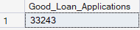

3. Good Loan Funded Amount
select SUM(loan_amount) as Good_Loan_Funded_Amount from bank_loan_data
where loan_status = 'Fully paid' OR loan_status = 'Current'
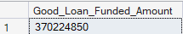

4. Good Loan Received Amount
select SUM(total_payment) as Good_Loan_Received_Amount from bank_loan_data
where loan_status = 'Fully paid' OR loan_status = 'Current'
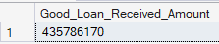

Bad Loans
1. Bad Loan Application Percentage
select (COUNT (CASE WHEN loan_status ='Charged Off' THEN id END )*100)
/COUNT (id) as Bad_Loan_Percentage from bank_loan_data

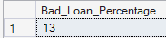

2. Bad Loan Applications
select COUNT(id) as bad_Loan_Applications from bank_loan_data
where loan_status = 'Charged Off'
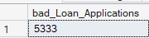

3. Bad Loan Funded Amount
select SUM(loan_amount) as Bad_Loan_Funded_Amount from bank_loan_data
where loan_status = 'Charged Off'
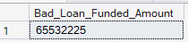

4. Bad Loan Received Amount
select SUM(total_payment) as Bad_Loan_Received_Amount from bank_loan_data
where loan_status = 'Charged Off'
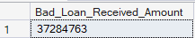

select loan_status,
COUNT (id) AS Total_Loan_Applications,
SUM(total_payment) as Total_Amount_Received,
SUM(loan_amount) as Total_Funded_Amount,
AVG (int_rate*100) as DTI
from bank_loan_data
Group by loan_status
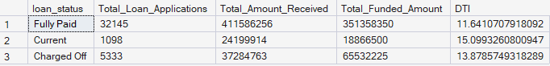

- MTD Total Amounted Received & MTD Total Funded Amount
select loan_status,
SUM(total_payment) as MTD_Total_Amount_Received,
SUM(loan_amount) as MTD_Total_Funded_Amount
From bank_loan_data
WHERE MONTH (issue_date) =12 and YEAR(issue_date) =2021
Group by loan_status

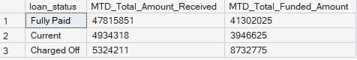

CHARTS:
1. Monthly Trends by Issue Date (line chart)
select
MONTH (issue_date) as Month_Name,
DATENAME(MONTH,issue_date) as Month_Name,
COUNT(id) as Total_Loan_Applications,
Sum(loan_amount) as Total_Funded_Amount,
sum(total_payment) as Total_Received_Amount
from bank_loan_data
group by MONTH (issue_date), DATENAME(MONTH,issue_date)
order by MONTH (issue_date)

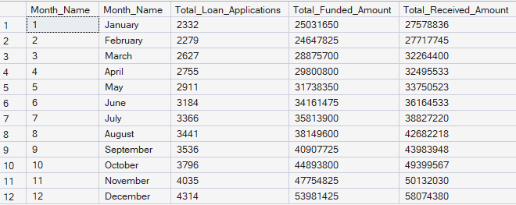

2. Regional Analysis by State (Filled map)
select
address_state,
COUNT(id) as Total_Loan_Applications,
Sum(loan_amount) as Total_Funded_Amount,
sum(total_payment) as Total_Received_Amount
from bank_loan_data
group by address_state
order by Count(id) desc

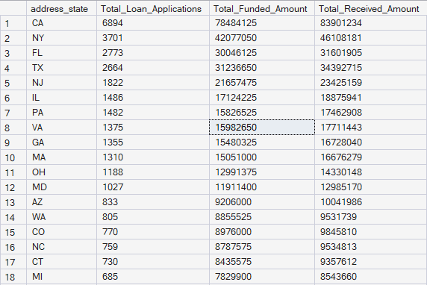
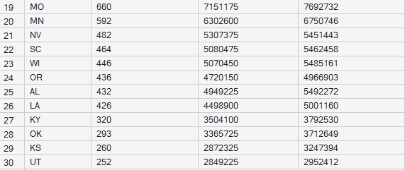

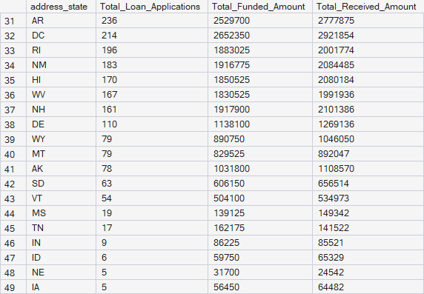

3.Loan Term Analysis (Donut Chart)
select
term,
COUNT(id) as Total_Loan_Applications,
Sum(loan_amount) as Total_Funded_Amount,
sum(total_payment) as Total_Received_Amount
from bank_loan_data
group by term
order by term

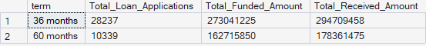

4.Employee Length Analysis (Bar Chart)
select
emp_length,
COUNT(id) as Total_Loan_Applications,
Sum(loan_amount) as Total_Funded_Amount,
sum(total_payment) as Total_Received_Amount
from bank_loan_data
group by emp_length
order by COUNT(id) desc

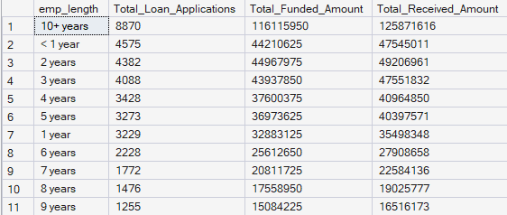

5. Loan Purpose Breakdown (Bar Chart0
select
purpose,
COUNT(id) as Total_Loan_Applications,
Sum(loan_amount) as Total_Funded_Amount,
sum(total_payment) as Total_Received_Amount
from bank_loan_data
group by purpose
order by COUNT(id) desc

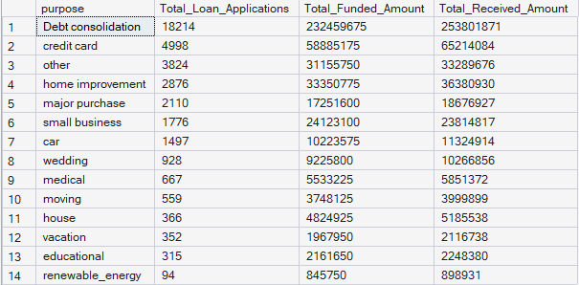

6. Home Ownership Analysis (Tree Map)
select
home_ownership,
COUNT(id) as Total_Loan_Applications,
Sum(loan_amount) as Total_Funded_Amount,
sum(total_payment) as Total_Received_Amount
from bank_loan_data
group by home_ownership
order by COUNT(id) desc

